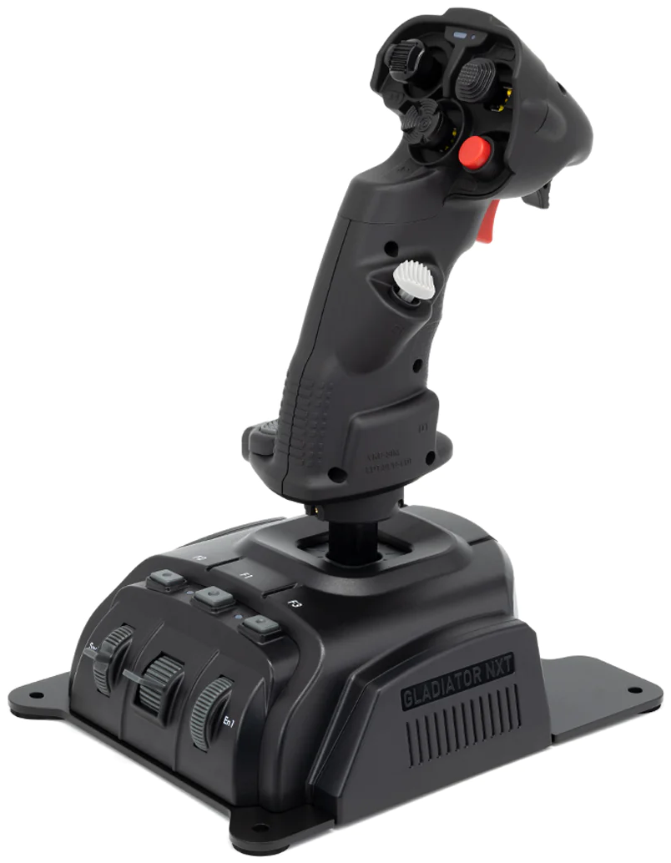
106 - Controls - WSO - Throttle Grip (Left Hand Controller)
U=Up, D=Down, F=Forward, B=Backward, L=Left, R=Right, P=Press, S-*=Shift-*, L-*=Long-*

Top Hat -- "Castle Switch" (RHC)
 | TPOD | HRM/RBM | BCN | Set | TSD | A/A radar | A/G weapon
F: | Cursor blank | Cursor map | Cursor map | -- | Decrease map scale | MRM search mode | TODO
B: | Target | Target | Target | Target | Increase map scale | SRM search mode | TODO
L: | Cursor cue | Cursor cue | -- | Cue | Toggles radar/FLIR cue | Undesignate | TODO
R: | Cursor update | Cursor update | -- | Cursor update | -- | Missile reject | TODO
P: | Sequence point select | Sequence point select | Sequence point select | Sequence point select | Sequence point select | Quick step (returns TDC cursor to STT) | TODO
Top Hat Ring -- "Antenna elevation control"
- F/B: Antenna elevation up/down
Middle Hat -- "Communications switch"
- U: (SRS radio 1 PTT)
- D: (SRS radio 2 PTT)
- S-U: Radio 1 PTT (opens comms menu for radio 1)
- S-D: Radio 2 PTT (opens comms menu for radio 2)
Bottom Hat -- "Auto Acquisition Switch aka Mode Reject/FOV" (LHC)
 | TPOD | HRM/RBM | A/A radar | TSD | A/G weapon
F: | Narrow/Wide FOV | Smaller window/range | High data rate TWS/RAM | Smaller cue footprint | TODO
P: | Undesignate | Mode reject; PSL/Undesignate | Mode reject | Return to P.P. (present position) map | TODO
B: | Return to cue | Larger window/range | Normal TWS | Larger cue footprint | TODO
Front/Rear Thumb Button -- "Trigger stage 1" (LHC)
 | TPOD | HRM | A/A radar | RBM/BCN | TSD | A/G weapon
P1: | Track/Untrack | Expand enable; PPI range change enable | Elevation slew enable | Elevation slew enable; PPI range change enable | Track/Untrack | Track command
Rear Thumb Button -- "Trigger stage 2" (LHC)
 | TPOD | HRM | A/A radar | RBM/BCN | TSD | A/G weapon
P2: | Designation/Cue/Update | Designation/Cue/Update | Target designation | Designation/Map/Cue/Update | Cue command | Track command
Bottom Thumb Button
- P: --
- S-P: --
Ministick -- "TDC/Throttle Designator Controller" (LHC)
- Axes: Slew TDC
- P: Designate; Expand HRM
Middle Finger Hat -- "Coolie" (LHC)
- U: Scroll left inboard MFD page (2nd MFD)
- D: Scroll left outboard MFD page (1st MFD)
- L: Take command left outboard MFD (1st MFD)
- R: Take command left inboard MFD (2nd MFD)
Ring Finger Slider
- U/D: --
Pinky Switch -- "CMD Dispenser Switch" (LHC)
- U: Manual 1 dispense
- D: Manual 2 dispense (semi-automatic)
- P: --
Pinky Button -- "Laser Fire Button"
 | TPOD | HRM/RBM | A/G weapon
P: | Laser fire toggle | Freeze/Unfreeze | TODO
Pinky Wheel
- F/B: --
- P: --

